DISD

XX/09/2021

I, Raphael Son Hing hereby declare that I did not plagiarize any content in this assignment and that this my own work.  
Signed:_______________

Programming 2b Task 1

Raphael Son Hing 15004658

Contents

2 Introduction 2

3 Overview 3

4 Conclusion 7

5 Various Screenshots 8

6 References 12

# Introduction

Salutations, in this, I have been presented with the task of making a program generally to assisting to compile a timetable appliable to class hours.

Though the instructions are somewhat vague enough that I cannot accurately visualize what was the intended end goal, I have tried my best to fulfil the various criteria.

Here are the github and youtube links.

<https://youtu.be/BcYXquLEJu0>

https://github.com/RaphaelSH/PROGRAMMING2BPOE-Task1-15004658-Raphael_Son_Hing

# Overview

Especially noting that the instructions specifically mentioned that the data does not need to be saved outside the activation of the program, I interpreted this as that the need to include various databases or saving information unnecessary.

He basis design is shown.

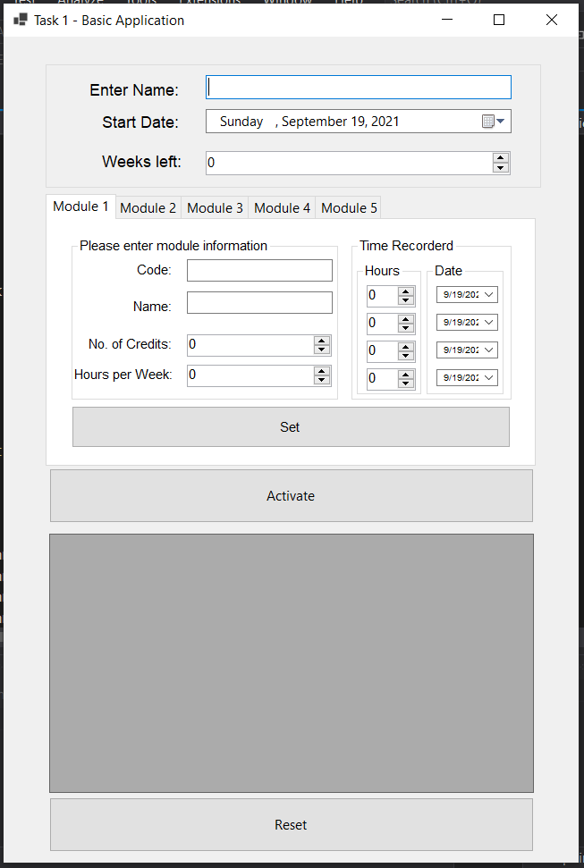

Notably, at various points the instructions deem that I place several areas to handle date and time input, however they don’t seem to have a functional purpose beyond that, and they user can enter the data but it does not have any effect on the program their initial recording.

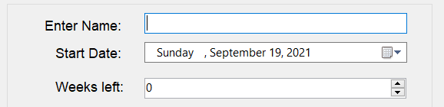

Enter the user’s name, followed by the start date and weeks left.

The theme of reason of why these entries are grouped together is they are universal constants throughout the modules and are not necessary to be changed when inputting new entries.

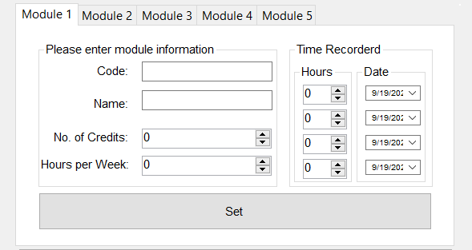

For convince sake, I have opted to include tabs to enter more entries, one reason is the simplicity to make it easier to use, another reason is as we are recording modules, the amount of entries typically so high an amount that can’t be handled by such a format. Modules do not stray in number by much than 4 or so.

The vital part of this, is that the correct data can only inputted to achieve the required result, so the various input boxes have been set to only allow the correct values to be accepted. If an improper value is put in, a pop-up message shall come in to play and inform the user as so.

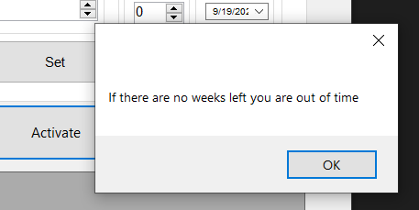

One can switch tabs to input different entries, where identical interfaces are ready to be used.

One must always remember to press the set buttons afterwards. This button records the data into the programs and without pressing it, the data will not be saved and will be ignored in the final result.

Another feature is when a module is set, the tab name displayed will be changed to reflect that, ensuring an easier time organizing and will be helpful identifying the tab if one wants to go back.

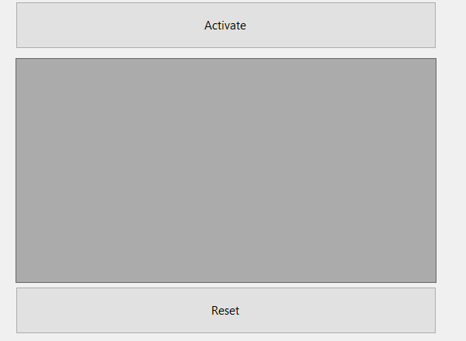

The “Activate” button compiles all the data inputted so far and displays it in the box below. Information for tabs that are left blank are left out to prevent clutter and confusion.

Utilizing the following required formula provided as stipulated.

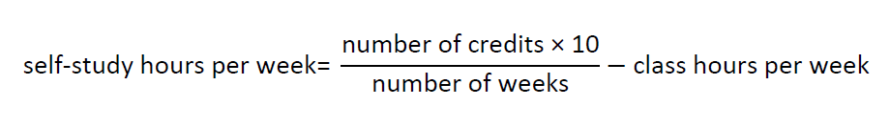

Information is derived and put into effect.

An example of the display is as follows.

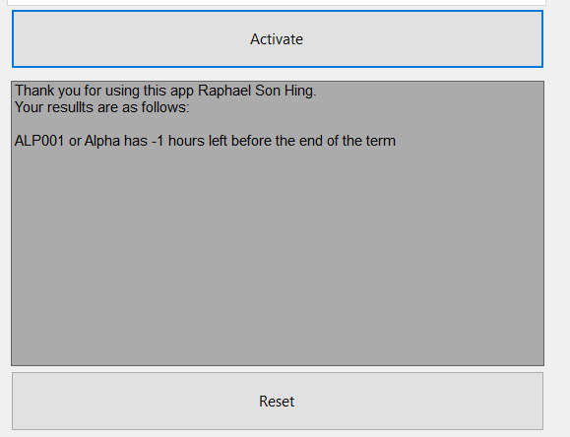

The reset button coverts all the information included in the tabs into a clean state so that the user can restart from the beginning.

Although one can just go back and update the information for the same result, alternately this option an instead reverts them.

# Conclusion

Through the accumulation of my efforts making this program, the most invaluable experience is how to prevent the user for intentionally enter correct values, such as forgetting to input how many weeks left results in a “divide by zero” scenario. And various countermeasures have to be implemented, from only allowing number to be set in various places, to implementing pop-ups to inform the user.

Following the concept of a basic program I have chosen the methods I think are most applicable to the scenario. As the Bahaus art movement claimed “form follows function” I made efforts supporting that ideal. From easy to use by sight, anyone can quickly adapt to the program.

Design appeal is left to standard without any extreme changes in appearance, such as radical colour changes and adding images, attaching on the the idea is “simple is best” when making this program into reality.

# Various Screenshots



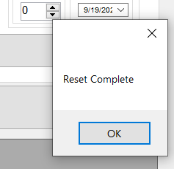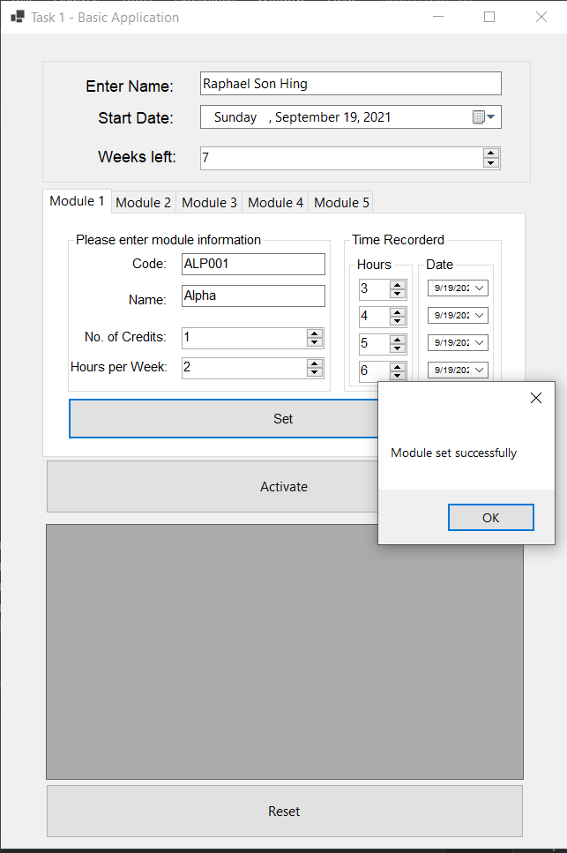

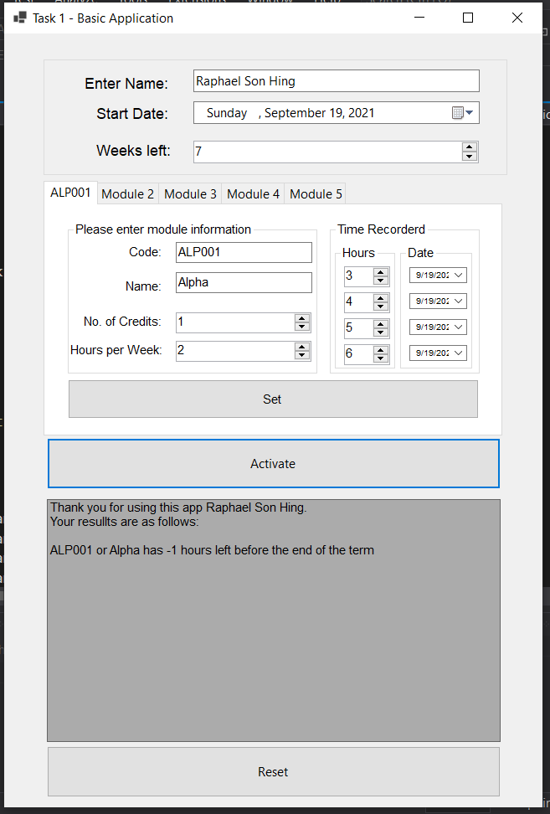

# References

Unknown. (2018, May 18). *DBMS Database Models*. Retrieved from studytonight.com: https://www.studytonight.com/dbms/database-model.php

Unknown. (2018, May 18). *What are Databases? - Examples & Types*. Retrieved from study.com: https://study.com/academy/lesson/what-are-databases-examples-types-quiz.html

Unknown. (2018, May 18). *What is a Database Model* . Retrieved from lucidchart.com: https://www.lucidchart.com/pages/database-diagram/database-models

Unknown. (2021, May 1). *Registration Forms*. Retrieved from Jotform: https://www.jotform.com/form-templates/category/registration

Zameer, A. (2007, December 13). *PHP read text file and insert into MySQL database*. Retrieved from Web Develoment Blog 24: https://www.wdb24.com/php-read-text-file-and-insert-into-mysql-database/#google_vignette